**IMPACT OF INTERNET USAGE ON SLEEP PATTERNS AMONG YOUNG ADULTS**

**Higher National Diploma in Software Engineering**

**24.1F**



**School of Computing and Engineering**

**National Institute of Business Management**

**Kandy**

**Declaration**

This statistical analysis is submitted as the coursework for the module Statistic in Higher National Diploma in Software Engineering. I certify that this is our own work and, it does not contain any material previously published or written by another person or myself except where due reference is made in the text. It is our own work which is analyzed through researched data

Students:

|  |  |  |
| --- | --- | --- |
| Index Number | Name | Signature |
| KAHDSE241F-022 | Zeena Zulfi |  |
| KAHDSE241F-024 | Arun Jonathan |  |
| KAHDSE241F-028 | A.Dhanushanandan |  |
| KAHDSE241F-027 | Nabeel Fazeel |  |

**Table of Contents**

**Chapter 1: Introduction** 4

**1.1 Introduction** 4

**1.2 Key factors and their Impact** 5

**1.3 Objectives** 6

**2.1 Analysis** 7

**Descriptive Statistics** 7

**Correlation Coefficient** 11

**Regression Analysis** 14

**Result and Discussions** 15

**Conclusion** 16

**Recommendations** 17

**References** 17

# **Chapter 1: Introduction**

## **1.1 Introduction**

In this digital age, Internet usage in central to education, social interaction, and leisure, particularly for young adults. However, it’s impact on health, especially sleep patterns, is becoming a concern. Sleep, vital for physical and mental well-being, is increasingly disrupted by excessive internet use. Activities like social media, online gaming, and streaming, often late into the night, lead to reduced sleep, difficulty falling asleep, and poor sleep quality. The stimulating nature of online activities and the blue light from screens further disrupt sleep cycles.

This research investigates the link between internet use and sleep among young adults, focusing on how prolonged screen time and specific online behaviors contribute to sleep disturbances. By analyzing sleep quantity and quality, it seeks to uncover risk factors related to the poor sleep hygiene. The study aims to highlight the growing issue of sleep deprivation and offer recommendations to promote healthier internet use and better sleep habits. Understanding the relationship between technology and sleep is essential to addressing the health challenges faced by today’s youth.

## **1.2 Key factors and their Impact**

Time spent on Internet:

Extended internet usage, particularly late at night, can lead to reduced sleep duration, difficulty falling asleep, and poor sleep quality. Prolonged screen exposure stimulates the brain, making it harder to unwind before bedtime

Time taken to fall asleep:

The stimulating content on the Internet and the blue light emitted by screens can delay the onset of sleep by interfering with melatonin production, the hormone that regulates sleep-wake cycles. This can result in increased time to fall asleep, causing sleep deprivation.

Hours of sleep you get in an average Night:

Excessive internet usage often leads to shorter sleep durations, Insufficient sleep can negatively affect cognitive functioning, emotional regulation, and overall physical health. Sleep deficits may accumulate over time, leading to chronic fatigue.

Staying up to use the Internet:

Staying up late to engage in online activities, such as gaming or social media, can disrupt natural sleep schedules. This behavior often results in fewer hours of sleep, poorer sleep quality, and the development of irregular sleep patterns, which can affect daytime functioning.

Experience any negative feelings when you can’t access the Internet:

Experiencing negative emotions when unable to access the internet may indicate internet dependence or addiction. This emotional distress can interfere with sleep by causing restlessness, rumination, and increased stress levels, all of which affect the sleep quality.

\

## **1.3 Objectives**

To assess the relationship between time spent on internet and sleep quality among young adults:

This objective aims to quantify how prolonged internet use affects the quality of sleep, including sleep disturbances and restfulness.

To examine the correlation between internet use before bedtime and the time it takes to fall asleep:

The goal is to explore whether pre-sleep internet activity contributes to delays in falling asleep and identify specific types of online behaviors that aggravate this delay

To determine the impact of internet usage in the total hours of sleep young adults get on average:

This objective focuses on understanding how internet usage affects sleep duration and whether frequent internet users tend to get less sleep than recommended.

To investigate the prevalence of staying up late for internet use and its effect on sleep patterns:

The aim is to explore how often young adults sacrifice sleep for internet activities and how this behavior leads to irregular sleep schedules and sleep deprivation.

To explore the emotional and psychological effects of internet f=deprivation on sleep quality:

This objective will study the negative feeling experiences when unable to access the internet and how much emotions contributes to stress or anxiety, which in turn affect sleep quality and duration.

# **2.1 Analysis**

### **Descriptive Statistics**

This is the data analysis according to our analysis based on the Impact of internet usage on sleep patterns among young adults. This categorization is done to analyze this better and more efficiently.

|  |  |  |  |  |  |  |  |  |  |  |
| --- | --- | --- | --- | --- | --- | --- | --- | --- | --- | --- |
| **Variable** | **Mean** | **StDev** | | **Variance** | | **CoefVar** | **Sum** | **Q1** | **Median** | **Q3** |
| Age | 2.6447 | 0.8116 | | 0.6588 | | 30.69 | 201.0000 | 2.0000 | 3.0000 | 3.0000 |
| District | 6.959 | 3.493 | | 12.204 | | 50.20 | 515.000 | 5.000 | 5.000 | 8.250 |
| Time spent on internet | 3.079 | 1.197 | | 1.434 | | 38.89 | 234.000 | 2.000 | 3.000 | 4.000 |
| Time taken to fall asleep | 2.421 | 1.169 | | 1.367 | | 48.29 | 184.000 | 2.000 | 2.000 | 4.000 |
| Hours of sleep you get in night | 3.171 | 1.269 | | 1.610 | | 40.02 | 241.000 | 2.250 | 4.000 | 4.000 |
| Staying up to use internet | 3.197 | 1.033 | | 1.067 | | 32.31 | 243.000 | 2.000 | 4.000 | 4.000 |
| Experience any negative feeling | 2.658 | 1.260 | | 1.588 | | 47.41 | 202.000 | 1.000 | 3.000 | 4.000 |
| **Variable** | **Mode** | | **N for Mode** | |
| Age | 3 | | 41 | |
| District | 5 | | 37 | |
| Time spent on internet | 3 | | 22 | |
| Time taken to fall asleep | 2 | | 40 | |
| Hours of sleep you get in night | 4 | | 50 | |
| Staying up to use internet | 4 | | 43 | |
| Experience any negative feeling | 4 | | 30 | |
|  |  | |  | |
|  |  | |  | |

|  |  |  |  |  |
| --- | --- | --- | --- | --- |
| **Original Value** | **Recoded Value** | | **Number of Rows** | |
| 15 - 17 years old | 1 | | 5 | |
| 18 - 21 years old | 2 | | 25 | |
| 22 - 24 years old | 3 | | 41 | |
| 25 - 27 years old | 4 | | 2 | |
| More than 27 | 5 | | 3 | |
| Source data column | | Age | |
| Recoded data column | | Recoded Age | |

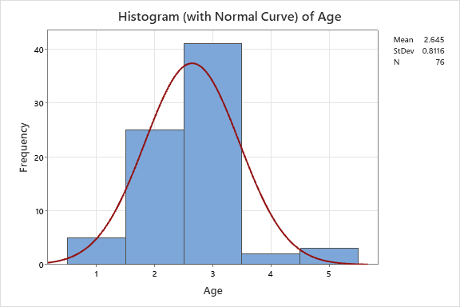

|  |  |  |  |  |
| --- | --- | --- | --- | --- |
| **Original Value** | **Recoded Value** | | **Number of Rows** | |
| Badhulla | 1 | | 1 | |
| Badulla | 2 | | 1 | |
| Gampaha | 3 | | 1 | |
| Good | 4 | | 1 | |
| Kandy | 5 | | 37 | |
| Kandy | 6 | | 10 | |
| Kegalle | 7 | | 3 | |
| Kegalle | 8 | | 2 | |
| Kndy | 9 | | 1 | |
| Kurunegala | 10 | | 4 | |
| Kurunegala | 11 | | 5 | |
| London | 12 | | 1 | |
| matale | 13 | | 1 | |
| Matale | 14 | | 2 | |
| Matale | 15 | | 1 | |
| Monaragala | 16 | | 1 | |
| Nuwara eliya | 17 | | 1 | |
| කුරුණෑගල | 18 | | 1 | |
|  | * | | 2 | | |
| Source data column | | District | |
| Recoded data column | | Recoded District | |

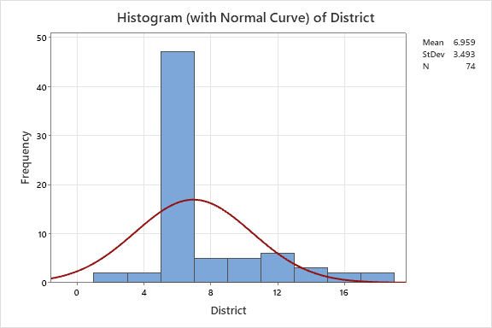

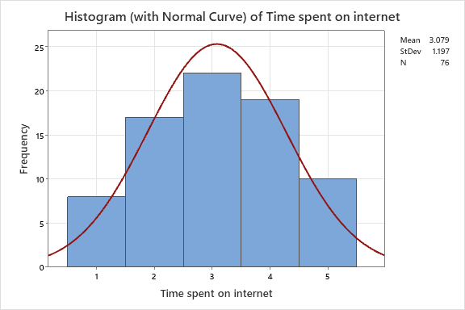

|  |  |  |  |
| --- | --- | --- | --- |
| **Original Value** | **Recoded Value** | | **Number of Rows** |
| 0 - 2 hours | 1 | | 8 |
| 2 - 4 hours | 2 | | 17 |
| 4 - 6 hours | 3 | | 22 |
| 6 - 8 hours | 4 | | 19 |
| More than 8 | 5 | | 10 |
| Source data column | | Time spent on Internet | | |

|  |  |  |  |
| --- | --- | --- | --- |
| **Original Value** | **Recoded Value** | | **Number of Rows** |
| 1 Hour | 1 | | 14 |
| 15 Minutes | 2 | | 40 |
| 2 Hour | 3 | | 2 |
| 30 Minutes | 4 | | 16 |
| More than 3 hours | 5 | | 4 |
| Source data column | | Time taken to fall asleep | | |
| Recoded data column | |  | | |

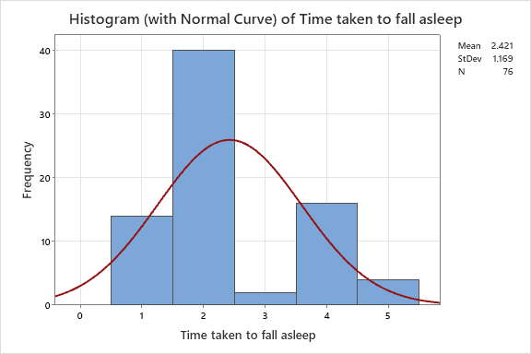

|  |  |  |  |
| --- | --- | --- | --- |
| **Original Value** | **Recoded Value** | | **Number of Rows** |
| 5 hours | 1 | | 18 |
| 7/6hr | 2 | | 1 |
| less than 5 hours | 3 | | 7 |
| More than 5 hours | 4 | | 50 |
| Source data column | | Hours of sleep you get | | |
| Recoded data column | | Recoded Hours of sleep you get | | |

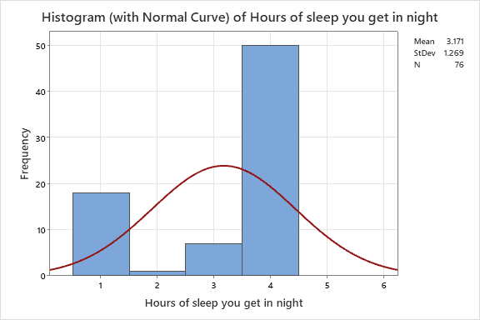

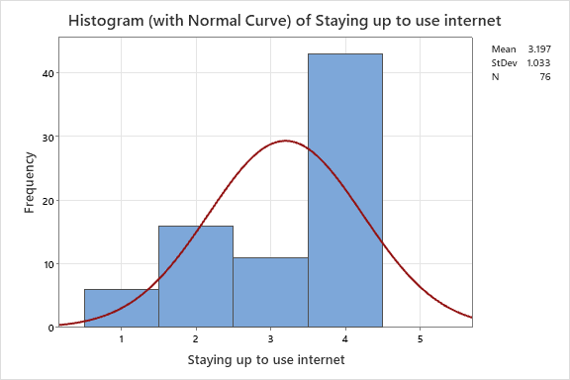

|  |  |  |  |
| --- | --- | --- | --- |
| **Original Value** | **Recoded Value** | | **Number of Rows** |
| Never | 1 | | 6 |
| Often | 2 | | 16 |
| Rarely | 3 | | 11 |
| Sometimes | 4 | | 43 |
| Source data column | | Stay up to use internet | | |
| Recoded data column | | Recoded Stay up to use internet | | |

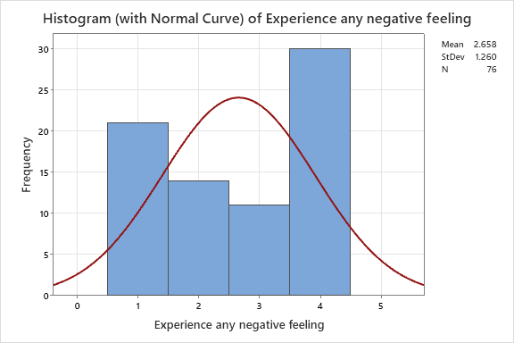

|  |  |  |  |
| --- | --- | --- | --- |
| **Original Value** | **Recoded Value** | | **Number of Rows** |
| Never | 1 | | 21 |
| Often | 2 | | 14 |
| Rarely | 3 | | 11 |
| Sometimes | 4 | | 30 |
| Source data column | | Experience any negative feeling | | |
| Recoded data column | | Recoded Experience any negative | | |

### **Correlation Coefficient**

Time spent on Internet VS Hours you get sleep in night

**Correlations**

|  |  |
| --- | --- |
|  | **Time spent on internet** |
| Hours of sleep you get in night | 0.070 |

The correlation coefficient between time spent on the internet and hours of sleep per night is 0.070. This indicates a positive but very weak relationship between these two variables. The positive value suggests that as the time spent on the internet increases, there is a slight tendency for the hours of sleep to also increase.

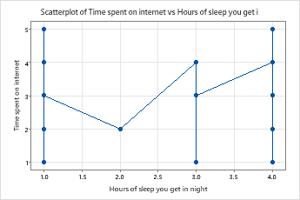

The scatter plot of time spent on internet vs hours of sleep you get visually represents the relationship between these two variables. Each point on the plot corresponds to the time spent on internet.

Internet usage VS time taken to fall asleep

**Correlations**

|  |  |
| --- | --- |
|  | **Time spent on internet** |
| Time taken to fall asleep | 0.166 |
|  |  |

The correlation coefficient between time spent on the internet and time taken to fall asleep is 0.166. This indicates a positive but weak relationship between these 2 variables. The positive value suggests that as the time spent on the internet increases, the time it takes to fall asleep also tends to increase slightly. However, the effect is relatively small.

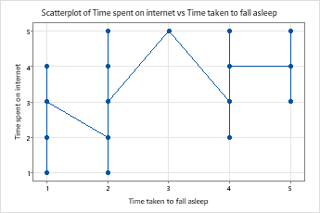

The scatter plot of time spent on internet vs time taken to fall asleep you get visually represents the relationship between these two variables. Each point on the plot corresponds to the time they take to sleep.

Staying up vs hours you sleep

**Correlations**

|  |  |
| --- | --- |
|  | **Staying up to use internet** |
| Hours of sleep you get in night | -0.016 |

The correlation coefficient between staying up to use the internet and the hours of sleep you get at night is -0.016. This indicates a very weak negative relationship between these 2 variables. The negative value suggests that the individuals stay up longer to use to internet, their hours of sleep may slightly decrease. However, the effect is minimal. A correlation of -0.016 is extremely close to zero, implying that there is almost no meaningful relationship between staying up late to use the internet and the amount of sleep a person gets.

So, in practical terms, staying up to use the internet appears to have a negligible impact on sleep duration.

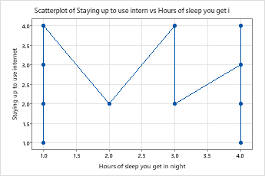

The scatter plot of staying up to use internet vs hours of sleep you get visually represents the relationship between these two variables. Each point on the plot corresponds to the hours they sleep when they use internet.

### **Regression Analysis**

Time spent on Internet VS Hours you get sleep in night

**Regression Equation**

|  |  |  |
| --- | --- | --- |
| Time spent on internet | = | 2.870 + 0.066 Hours of sleep you get in night |

Intercept ( 2.870 )

Slope ( 0.1493 )

There is a positive relationship between hours of sleep and time spent on the internet. As the number of hours of sleep increases, the time spent on the internet also slightly increases.

Internet usage VS time taken to fall asleep

**Regression Equation**

|  |  |  |
| --- | --- | --- |
| Time spent on internet | = | 2.666 + 0.170 Time taken to fall asleep |

Intercept ( 2.666 )

Slope ( 0.170 )

There is a positive relationship between the time taken to fall asleep and the time spent on the internet. As the time it takes to fall asleep increases, the time spent on the internet also increases slightly.

Staying up vs hours you sleep

**Regression Equation**

|  |  |  |
| --- | --- | --- |
| Staying up to use internet | = | 3.238 - 0.0130 Hours of sleep you get in night |
|  |  |  |

Intercept ( 2.870 )

Slope ( 0.1493 )

There is a negative relationship between hours of sleep and staying up to use the internet. As the hours of sleep increase, the time staying up to use the internet slightly decreases. However, the decrease is minimal.

# **Result and Discussions**

The statistical analysis of the impact of internet usage on sleep patterns among young adults.

The correlation between time spent on the internet and hours of sleep per night shows a very weak positive relationship. This indicates that increased internet usage does not significantly affect sleep duration.

Time spent on the internet and time taken to fall asleep shows there is a weak positive correlation between the time spent on the internet and the time it takes to fall asleep. This suggest that higher internet usage may lead to a longer time to fall asleep, but the impact is minimal.

The correlation between staying up to use the internet and hours of sleep shows a vert weak negative relationship. This indicates that staying up late for internet activities slightly reduces sleep duration, but the effect is so small that it is almost significant. This suggests that staying up to use the internet does not have a major impact on overall sleep quality

# **Conclusion**

The analysis of internet usage and its impact on sleep patterns among young adults reveals only weak relationships between these variables. While extended internet use shows a slight tendency to delay sleep onset and marginally reduce sleep duration, the effects are minimal. The weak positive correlation between time spent on the internet and sleep suggests that other factors, such as personal habits or the external influences, plays a more significant role in sleep disruption than internet usage alone.

In conclusion, although internet use has a small impact on sleep quality and duration, it is not a major factor in sleep disturbances for most young adults. This indicates that addressing other lifestyle factors may be more effective in promoting better sleep hygiene, and limiting internet use before bedtime could provide only modest benefits in improving sleep patterns.

# **Recommendations**

Focus on sleep hygiene:

Encourage young adults to improve their sleep hygiene by maintaining a proper sleep schedule, creating a proper bedtime routine and creating a comfortable sleep environment

Limit internet use before bedtime:

Limiting the screen time, particularly before bedtime, can improve sleep quality by reducing exposure to blue light and cam still help to promote a better sleep quality

Address lifestyle factors:

To improve the sleep, manage stress, improve diet with nutrient-rich meals, and engage in regular physical activities. These adjustments can disrupt sleep quality, promote relaxation, and help to reduce the stress, leading to significant improvements in sleep.

Educational programs:

Develop awareness programs for young adults about the impact of daily habits, such as internet use, on sleep quality.

Promote mindfulness and relaxations techniques:

Implement mindfulness, meditation or relaxation techniques to reduce stress and enhance sleep quality. Addressing non-internet-related factors that effects sleep.

# **References**

<https://www.ncbi.nlm.nih.gov/pmc/articles/PMC5353086/>

<https://youtu.be/tQBpEFP7t7s?si=NVinre9XEGos2ZHa>